**Software Engineer Project Report**

**CMPE 207**

*Online Grocery Database*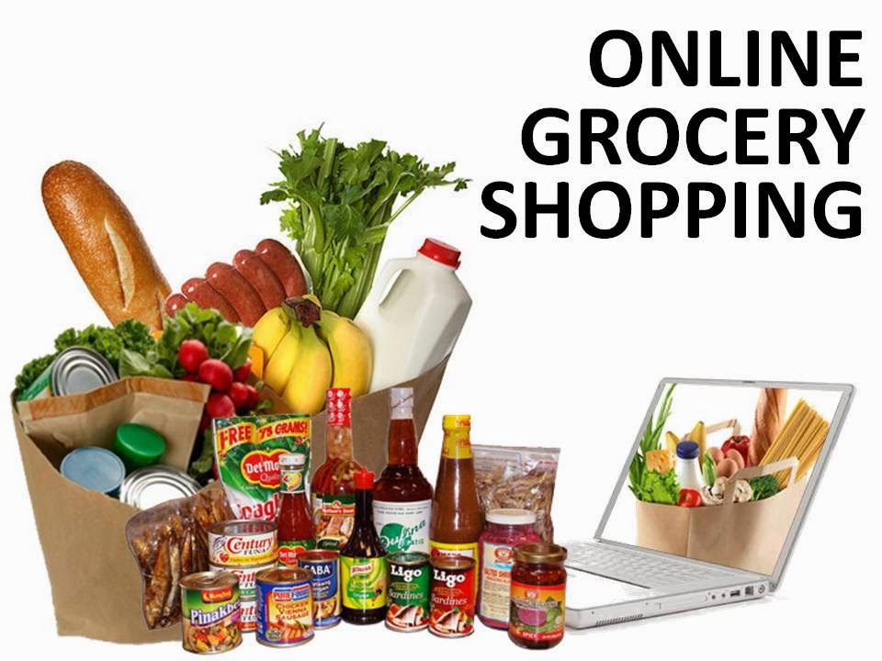

*Image source: from google images*

By:

Group 2: Tin Tran, Satish Kumar, Shiva Padma, Sreedeep Katragadda

Professor: Rakesh Ranjan

Abstract

Online grocery shopping is not a new idea, but they it’s not ideal for groceries that are being thrown away every year, wasting billions of dollars of perfectly good food. Families who cannot afford expensive should be able to buy the thrown away food at a discounted price. We provide a solution for that to happen.

1. **Background**

According to <http://www.worldfooddayusa.org/food_waste_the_facts> , in the US, 30-40% of the food supply is wasted, equaling to more than 20 pounds of food per person per month. One of the reason for this is because grocery stores have to discard and throw away products that no longer fresh or approaching expiration date, even though such products are perfectly fine to consume. Low income families who are on a budget should be able to buy these discounted products, since most online sites have to maintain the price for the newest and freshest products, and every store has different amount of food that they throw away. This makes it hard for consumers to find and buy the discounted groceries.

1. **Solution**

We provide a platform for local retailers to catalog and post their soon to be thrown away groceries, at a heavily discounted price. Local stores who have similar products can compete for the lowest price. And since customers can only buy these products at a local store, retailers don’t have to worry about shipping and handling, or online payment. On the other hand, budget conscious consumers who are looking to buy these discounted groceries will be able to find and buy them faster and much easier. Customers can get all the information about all the stores and their products in one central place, then make a choice for the store, saving time and money.

1. **The Implementation**

The structure of our solution resolves around Apache Server, PHP, MySQL, and a little of front end designing with HTML/CSS. Since none of us has had any significant experience with web design, this has proven to be a learning opportunity for us. We picked MySQL because it is a free and widely used database management system while offering almost all of the essential features. For a startup business, this will reduce the overhead and cost of buying and maintaining a more expensive DBMS such as Microsoft SQLServer or Oracle Database. We almost experimented with MariaDB, the successor of MySQL. For the database schema, we set up a table for customers, vendors, and products, which contain all the information such as name, address, product names, quantity, prices…We implemented some automation to check for the price and reduces it when 24 hours have passed. The automation also purges the data that goes past the sell by date. We chose Apacher Server and PHP to test the server side code that interact with the database from the front-end page. PHP is the fastest solution to implement, compared to other web frameworks such as Python Django or NodeJS. The front-end pages contain PHP scripts to insert and retrieving data from the database. We used Bootstrap templates for the front-pages as they were quick and easy to implement.

We also had plans for other features such as data analysis on which products are most likely get thrown away, or which products get bought the most. With this information, local retailers can choose to stock more or less particular items. Another point to mention is that currently we don’t have a solution to handle the online payment, as customers have to go to the stores, but with delivery services such as UberEats, DoorDash, this can be an opportunity for expansion,

1. **Conclusion**

While this project does not have the complexity compared to other projects, it provided us the opportunity to learn and get hands on with web development and databases. We hope to able to expand this project further to include blockchain, machine learning, and explore other areas of interests besides groceries.